Chapter 12
MANOVA
Using the Theories.csv dataset, instead of treating Environment as a covariant (as in the ANCOVA exercise), analyze it as a separate dependent variable. Thus, use MANOVA to evaluate if Environment and InputTime differ significantly depending on theoretical paradigm.
Check the assumptions before reporting the results but for simplicity, report the results 'as is' even though some assumptions may be violated. No data transformation will be conducted.
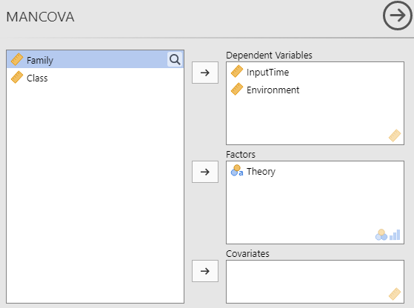

Box's Homogeneity of Covariance Matrices Test
χ² |  | df |  | p
58.9 |  | 6 |  | < .001

Q-Q Plot Assessing Multivariate Normality
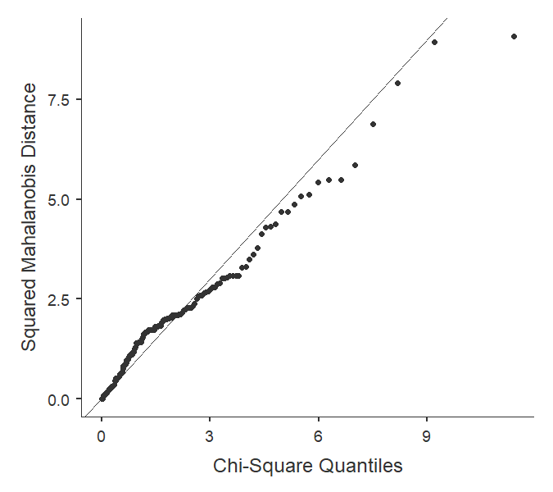

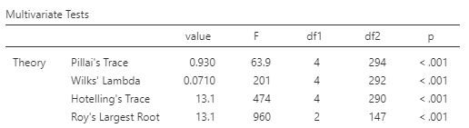
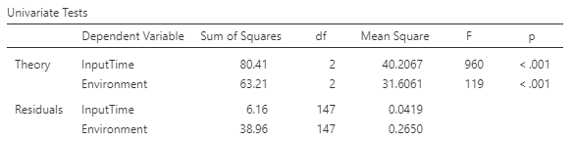

What do the assumption tests show?
Both sphericity and normality assumptions were not met.

What does the MANOVA show?
The multivariate analysis is significant (p <.001) showing that at least one of the two variables differs between the theories. Looking at the univariate results, both Theory and Environment have significantly different mean values.

