Chapter 11
ANCOVA
The Theories.csv file examines sociology professors' attitudes to the major sociological paradigms: Structural Functionalism, Symbolic Interactionism and Conflict Theory. The average teaching input time is one scale. The others are perceived relevance of each paradigm of the following areas of study: the Environment, Family, and Class. (This study is a fictional one, as usual, based on the Iris data set.)
We are interested in whether or not different amounts of teaching time are allocated to the different theories. Let us assume that the researchers consider the Environment to be rather a cause of confusion in theoretical terms, and would like to have the 'Environment' data taken into consideration as a potential cause of noise.

Check the assumptions before reporting the results but for simplicity, report the results 'as is' even though some assumptions may be violated. No data transformation will be conducted.
Set up ANCOVA as shown in the book, with InputTime as the dependent variable, Theory as the factor and Environment as a covariate. The following options are suggested:
- Homogeneity tests
- Normality (Q-Q plot)
- Post hoc tests for Theory (Tukey)
- Estimated marginal means section:
  - Theory in 'Term 1'
  - Marginal Means plots
  - Equal cell weights
  - Error bars, confidence intervals option
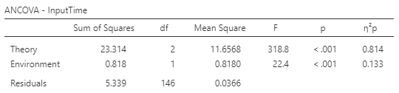
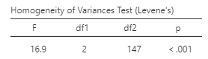

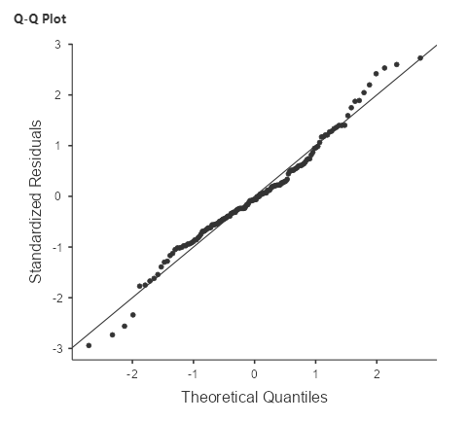

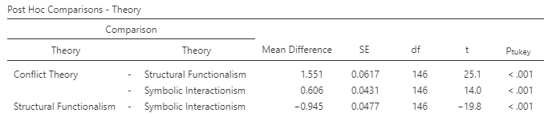

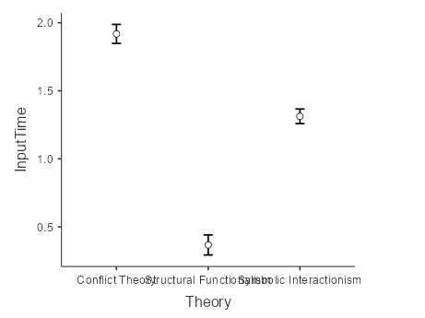

State the null and alternative hypotheses:
H0: The average teaching time is the same for all theories controlling for Environment
H1: The average teaching time differs between at least two types of theory controlling for Environment
What do the assumption results show?
The Levene’s Test statistic is significant (p <.05). Thus, the assumption of equality of variance was not met.
The normal Q-Q plot shows a satisfactory result. The standardized residuals plotted against their quantiles do not deviate from the normal line.
What do the ANCOVA results show?
The ANCOVA test shows a significant result both for the theories and Environment.
What is the result of a post-hoc test to identify significant differences among theories?
There are significant differences in teaching time between every theory.

