Chapter 11
ANCOVA
The Iris dataset quantifies the morphological variation of Iris flowers of three related species. It consists of 50 samples from each of three species of Iris—Iris setosa, Iris virginica, and Iris versicolor. The length and the width of the sepals and petals in centimeters were measured for each sample to compare the features per species.
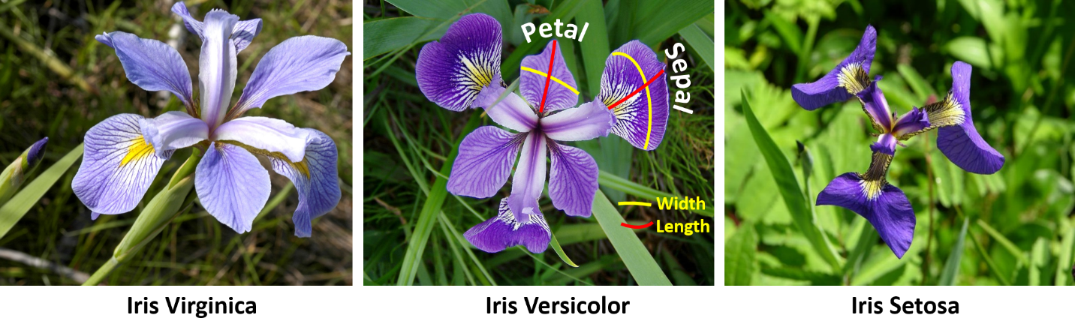
The data set Iris_data.csv contains this information. Input the data in Jamovi and analyze to see if there is a significant difference among the species’ petal widths and if this is affected by the sepal length, since the sepal is the part of the flower that supports the width.
Check the assumptions before reporting the results but for simplicity, report the results 'as is' even though some assumptions may be violated. No data transformation will be conducted.

State the null and alternative hypothesis:

What do the assumption results show?

What do the ANCOVA results show?

What is the result of a post-hoc test to identify significant differences among pairs of species?

