Chapter 18: The Kaplan Meier Survival Function
Consider a cohort of 20 participants who are 65 years of age and older, monitored for up to 24 years. Censoring occurs either when the study ends or they are lost to follow-up.
Load the data (Elder Mortality.csv) in Jamovi and analyze the Kaplan-Meier curve. If this is the first time you have used this application, load the 'Death Watch' module into Jamovi.
Year | Death
1 | Dead
2 | Censored
3 | Dead
5 | Dead
6 | Censored
8 | Dead
9 | Censored
10 | Censored
12 | Censored
13 | Censored
14 | Dead
16 | Dead
17 | Dead
18 | Censored
19 | Censored
20 | Dead
21 | Censored
22 | Dead
23 | Dead
24 | Censored

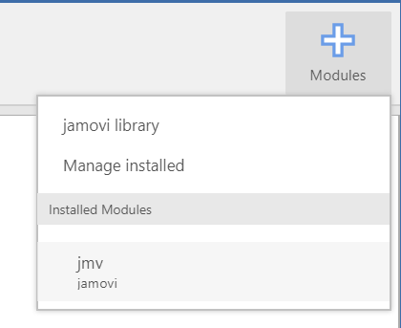
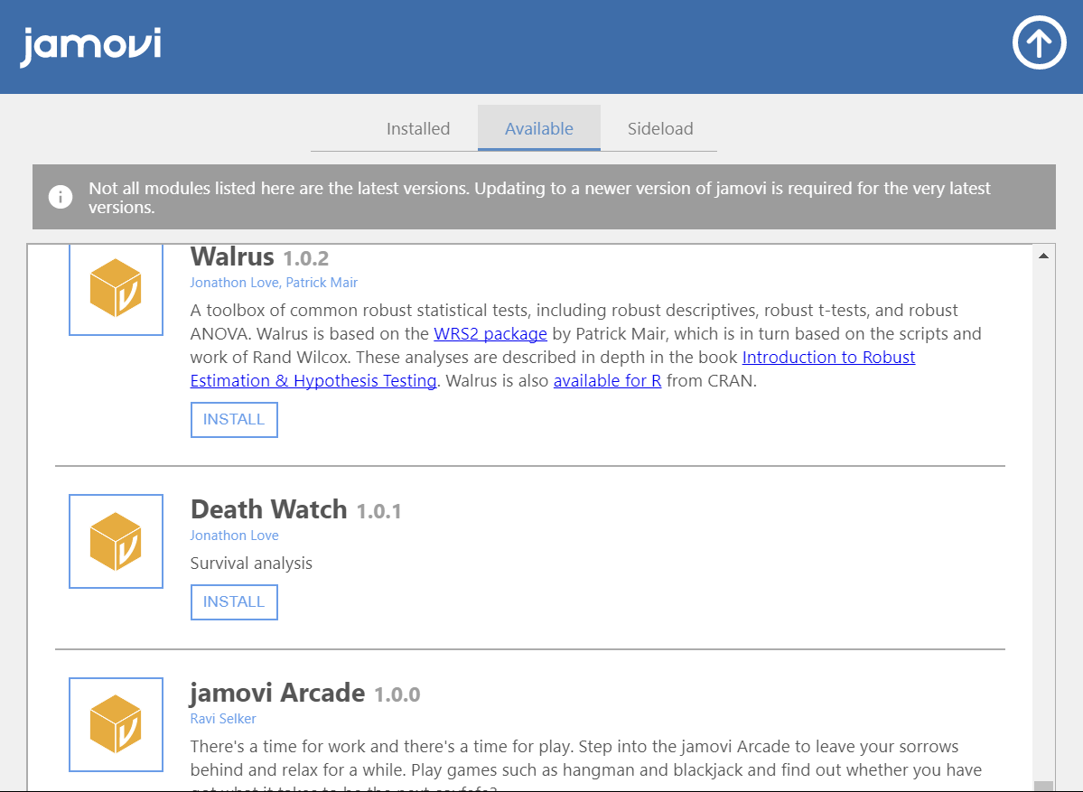

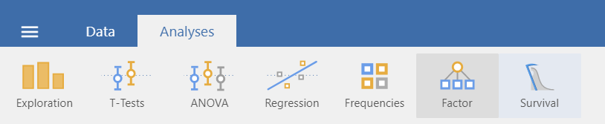

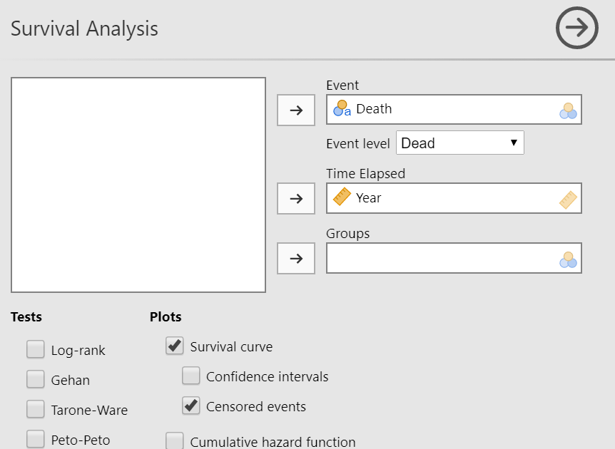

Survival Analysis
Survival Analysis
Censored |  | Events |  | N |  | Proportion |  | Median
10 |  | 10 |  | 20 |  | 50.0 % |  | 20.0

Survival Curve
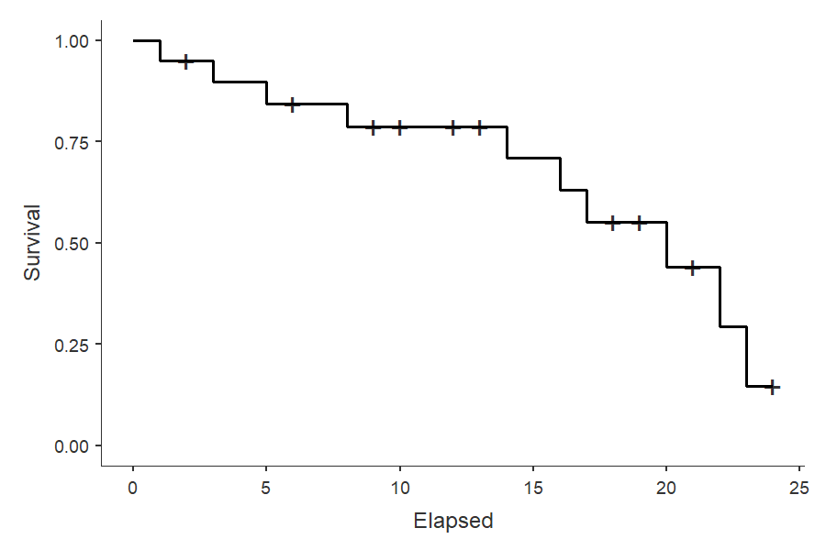

The median survival time is 20 years. This means that on the 20th year, half of the participants have already died or lost contact while the other half are still going on with the study. The curve also shows the third and first survival quartiles which are about on the 8th and 23rd year of the study respectively. Clearly, more deaths occur later on.

