Chapter 12
MANOVA
Using the Iris_data.csv dataset, instead of treating sepal length as a covariant (as in the ANCOVA exercise), analyze it as a separate dependent variable. Thus, use MANOVA to evaluate if petal width and sepal length differ significantly per species.
Check the assumptions before reporting the results but for simplicity, report the results 'as is' even though some assumptions may be violated. No data transformation will be conducted.
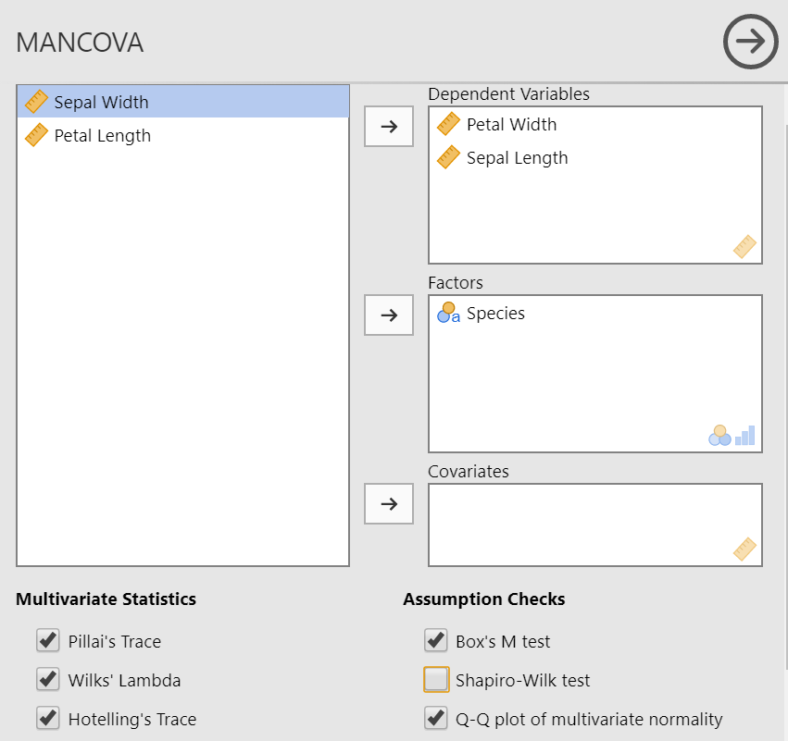

Box's Homogeneity of Covariance Matrices Test
χ² |  | df |  | p
58.9 |  | 6 |  | < .001

Q-Q Plot Assessing Multivariate Normality
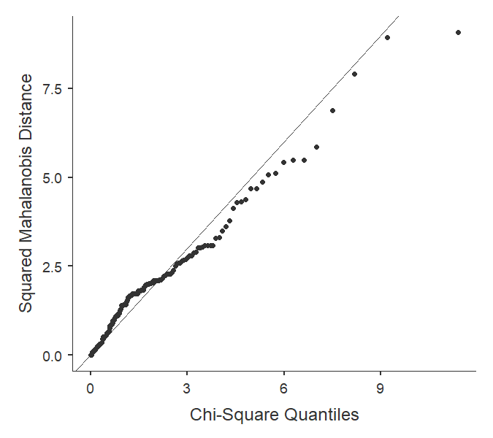

Multivariate Tests
 |  |  |  | value |  | F |  | df1 |  | df2 |  | p
Species |  | Pillai's Trace |  | 0.930 |  | 63.9 |  | 4 |  | 294 |  | < .001
 |  | Wilks' Lambda |  | 0.0710 |  | 201 |  | 4 |  | 292 |  | < .001
 |  | Hotelling's Trace |  | 13.1 |  | 474 |  | 4 |  | 290 |  | < .001
 |  | Roy's Largest Root |  | 13.1 |  | 960 |  | 2 |  | 147 |  | < .001

Univariate Tests
 |  | Dependent Variable |  | Sum of Squares |  | df |  | Mean Square |  | F |  | p
Species |  | Petal Width |  | 80.41 |  | 2 |  | 40.2067 |  | 960 |  | < .001
 |  | Sepal Length |  | 63.21 |  | 2 |  | 31.6061 |  | 119 |  | < .001
Residuals |  | Petal Width |  | 6.16 |  | 147 |  | 0.0419
 |  | Sepal Length |  | 38.96 |  | 147 |  | 0.2650

What do the assumption tests show?
Both sphericity and normality assumptions were not met.
What does the MANOVA show?
The multivariate analysis is significant (p <.001) showing that at least one of the two variables differs between the species. Looking at the univariate results, both petal width and sepal length have significantly different mean values among the iris species.

