Chapter 11
ANCOVA
The Iris dataset quantifies the morphological variation of Iris flowers of three related species. It consists of 50 samples from each of three species of Iris—Iris setosa, Iris virginica, and Iris versicolor. The length and the width of the sepals and petals in centimeters were measured for each sample to compare the features per species.
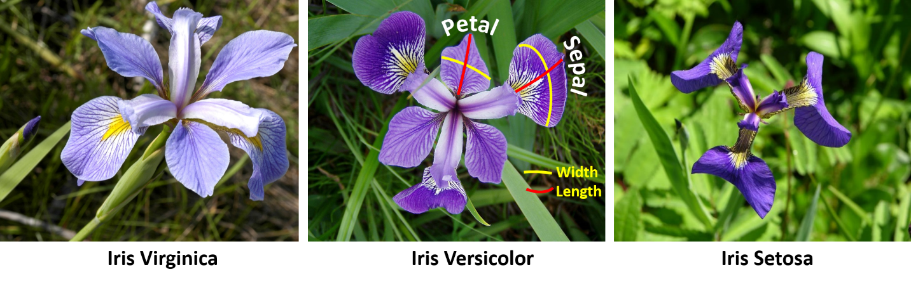
The data set Iris_data.csv contains this information. Input the data in Jamovi and analyze to see if there is a significant difference among the species’ petal widths and if this is affected by the sepal length, since the sepal is the part of the flower that supports the width.
Check the assumptions before reporting the results but for simplicity, report the results 'as is' even though some assumptions may be violated. No data transformation will be conducted.
Set up ANCOVA as shown in the book, with Petal Width as the dependent variable, Species as the factor and Sepal Length as a covariate. The following options are suggested:
- Homogeneity tests
- Normality (Q-Q plot)
- Post hoc tests for species (Tukey)
- Estimated marginal means section:
  - Species in 'Term 1'
  - Marginal Means plots
  - Equal cell weights
  - Error bars, confidence intervals option
ANCOVA - Petal Width
 |  | Sum of Squares |  | df |  | Mean Square |  | F |  | p |  | η²p
Species |  | 23.314 |  | 2 |  | 11.6568 |  | 318.8 |  | < .001 |  | 0.814
Sepal Length |  | 0.818 |  | 1 |  | 0.8180 |  | 22.4 |  | < .001 |  | 0.133
Residuals |  | 5.339 |  | 146 |  | 0.0366
Assumption Checks
Homogeneity of Variances (Levene's)
F |  | df1 |  | df2 |  | p
19.7 |  | 2 |  | 147 |  | < .001

Q-Q Plot
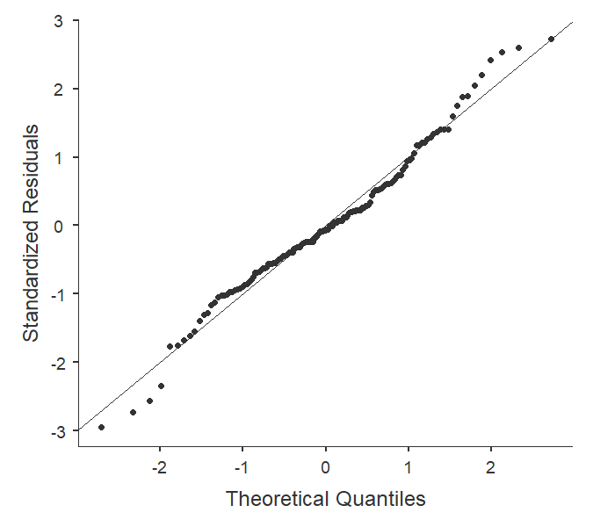
Post Hoc Tests
Post Hoc Comparisons - Species
Comparison
Species |  |  |  | Species |  | Mean Difference |  | SE |  | df |  | t |  | p_{tukey}
setosa |  | - |  | versicolor |  | -0.945 |  | 0.0477 |  | 146 |  | -19.8 |  | < .001
 |  | - |  | virginica |  | -1.551 |  | 0.0617 |  | 146 |  | -25.1 |  | < .001
versicolor |  | - |  | virginica |  | -0.606 |  | 0.0431 |  | 146 |  | -14.0 |  | < .001

Estimated Marginal Means Plot
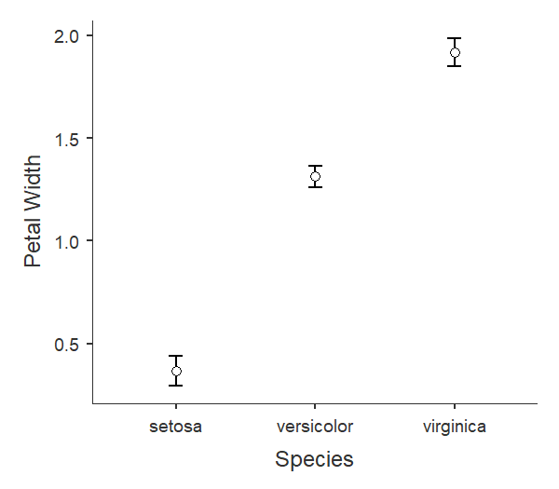
State the null and alternative hypothesis:
H0: The average petal width is the same for all iris species controlling for sepal length.
H1: The average petal width differs between at least two iris species controlling for sepal length.
What do the assumption results show?
The Levene’s Test statistic is significant (p <.05). Thus, the assumption of equality of variance was not met.
The normal Q-Q plot shows a satisfactory result. The standardized residuals plotted against their quantiles do not deviate from the normal line.
What do the ANCOVA results show?
The ANCOVA test shows a significant result both for the species and sepal length.
What is the result of a post-hoc test to identify significant differences among pairs of species?
There are significant differences in the petal width between every pair of species.

