Chapter 10
Repeated measures two-way ANOVA
Students’ levels of anxiety were measured based on two sources, examinations and bungee jumping. Both factors were measured pre- and post-activity. Each measurement used a scale of 1 to 10, 1 being the lowest and 10 being the highest. One of the factors is the source of anxiety; the other is time before and after the activity.
Perform a repeated measures two-way ANOVA in JASP to analyze the individual and interaction effects of activity and time on the students’ anxiety levels (on the Repeated-measures two-way ANOVA csv file).
PreExam_Anxiety | PostExam_Anxiety | PreBungee_Anxiety | PostBungee_Anxiety
6 | 5 | 9 | 7
9 | 6 | 6 | 4
5 | 3 | 8 | 5
6 | 2 | 5 | 5
6 | 5 | 9 | 6
3 | 3 | 7 | 5
9 | 6 | 7 | 5
4 | 2 | 4 | 3
8 | 5 | 6 | 5
7 | 2 | 8 | 4

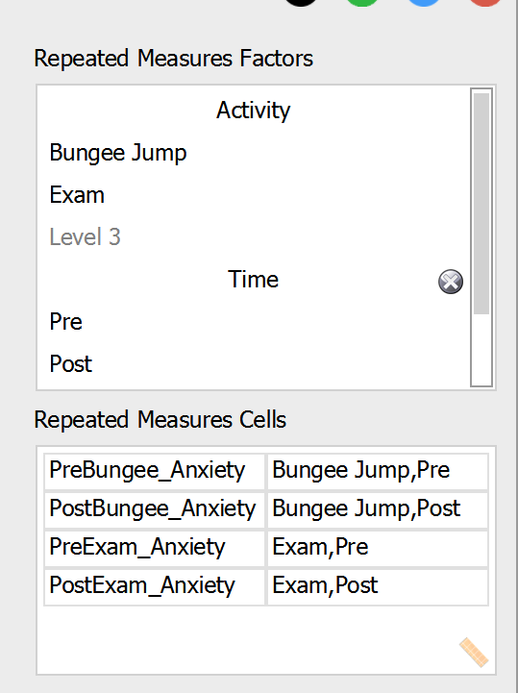

Within Subjects Effects
 |  | Sum of Squares |  | df |  | Mean Square |  | F |  | p |  | η² _{p}
Activity |  | 6.400 |  | 1 |  | 6.400 |  | 1.794 |  | 0.213 |  | 0.166
Residual |  | 32.100 |  | 9 |  | 3.567
Time |  | 48.400 |  | 1 |  | 48.400 |  | 53.778 |  | < .001 |  | 0.857
Residual |  | 8.100 |  | 9 |  | 0.900
Activity ✻ Time |  | 0.400 |  | 1 |  | 0.400 |  | 0.444 |  | 0.522 |  | 0.047
Residual |  | 8.100 |  | 9 |  | 0.900
Note. Type III Sum of Squares

The results show that only time has a significant effect since its p-value is less than 0.05. In addition, it has a very large effect size (use 'Additional Options' to find this). The interaction effect and the Activity effect are insignificant.
Between-Subjects ANOVA
A fiber company is analyzing the breaking strength of their product on several production batches. Four production machines are chosen, and the operator was also noted. The results are as follows (on the Between Subjects ANOVA csv file):
Breaking strength | Machine | Operator
109 | 1 | 1
110 | 1 | 1
110 | 1 | 2
112 | 1 | 2
116 | 1 | 3
114 | 1 | 3
110 | 2 | 1
115 | 2 | 1
110 | 2 | 2
111 | 2 | 2
112 | 2 | 3
115 | 2 | 3
108 | 3 | 1
109 | 3 | 1
111 | 3 | 2
109 | 3 | 2
114 | 3 | 3
119 | 3 | 3
110 | 4 | 1
108 | 4 | 1
114 | 4 | 2
112 | 4 | 2
120 | 4 | 3
117 | 4 | 3

Test to see if there is a difference in breaking strength according to the factors considered.
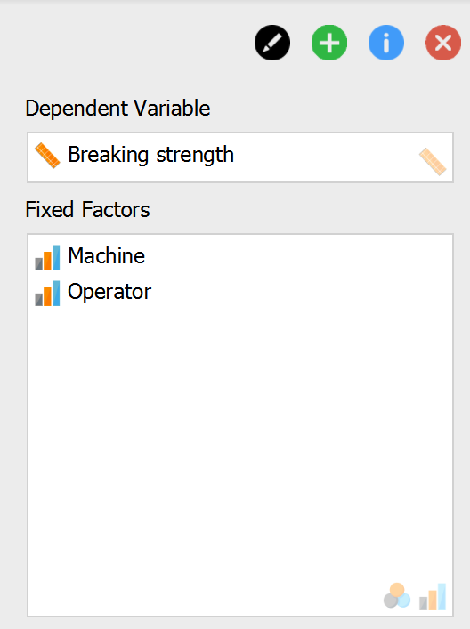

ANOVA - Breaking strength
Cases |  | Sum of Squares |  | df |  | Mean Square |  | F |  | p |  | η² |  | η² _{p}
Machine |  | 12.458 |  | 3.000 |  | 4.153 |  | 1.095 |  | 0.389 |  | 0.047 |  | 0.215
Operator |  | 160.333 |  | 2.000 |  | 80.167 |  | 21.143 |  | < .001 |  | 0.610 |  | 0.779
Machine ✻ Operator |  | 44.667 |  | 6.000 |  | 7.444 |  | 1.963 |  | 0.151 |  | 0.170 |  | 0.495
Residual |  | 45.500 |  | 12.000 |  | 3.792
Note. Type III Sum of Squares

Post Hoc Comparisons - Operator
 |  |  |  | Mean Difference |  | SE |  | t |  | p _{tukey}
1 |  | 2 |  | -1.250 |  | 0.974 |  | -1.284 |  | 0.430
 |  | 3 |  | -6.000 |  | 0.974 |  | -6.163 |  | < .001
2 |  | 3 |  | -4.750 |  | 0.974 |  | -4.879 |  | 0.001

Descriptives Plot
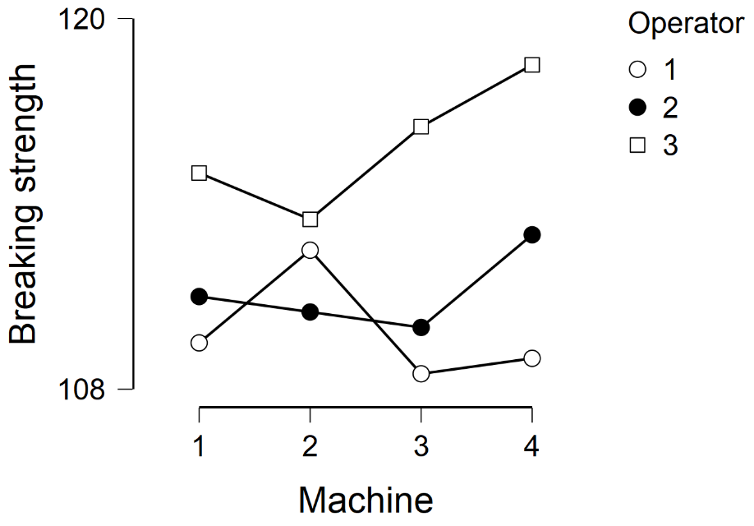

The ANOVA results show that the average breaking strength differs based upon the operator (the p value is lower than 0.05). Moreover, it has a very large effect size at 0.779. Since there are three operators, a post hoc test may be useful: operators 1 and 3 as well as 2 and 3 have significantly different effects on breaking strength. As shown in the plot, operator 3 has the highest average breaking strength for all machines..

Mixed ANOVA
The quality control department of a fabric dye company is analyzing the difference in quality of dyes produced by three machines. In addition, the department wants to study if the dyeing temperature affects the quality; different temperatures can be tried on the same machine. Below are the results (also on the Mixed ANOVA.csv file):

Cloth | Machine | 300_Temperature | 350_Temperature
1 | 1 | 23 | 24
2 | 1 | 24 | 23
3 | 1 | 25 | 28
4 | 2 | 30 | 38
5 | 2 | 28 | 36
6 | 2 | 26 | 35
7 | 3 | 31 | 34
8 | 3 | 32 | 36
9 | 3 | 29 | 39

Conduct a mixed ANOVA with JASP and identify which factors are associated with dye score.

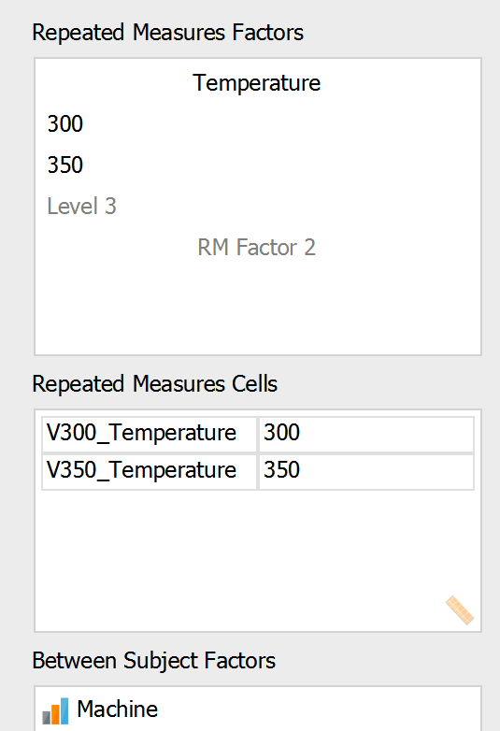

Results

Repeated Measures ANOVA
Within Subjects Effects
 |  | Sum of Squares |  | df |  | Mean Square |  | F |  | p |  | η² _{p}
Temperature |  | 112.500 |  | 1 |  | 112.500 |  | 36.161 |  | < .001 |  | 0.858
Temperature ✻ Machine |  | 41.333 |  | 2 |  | 20.667 |  | 6.643 |  | 0.030 |  | 0.689
Residual |  | 18.667 |  | 6 |  | 3.111
Note. Type III Sum of Squares

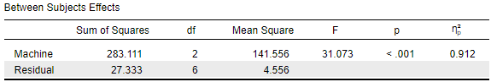

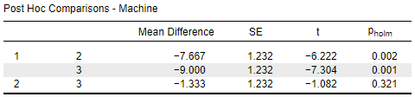

Descriptives

Descriptives Plot
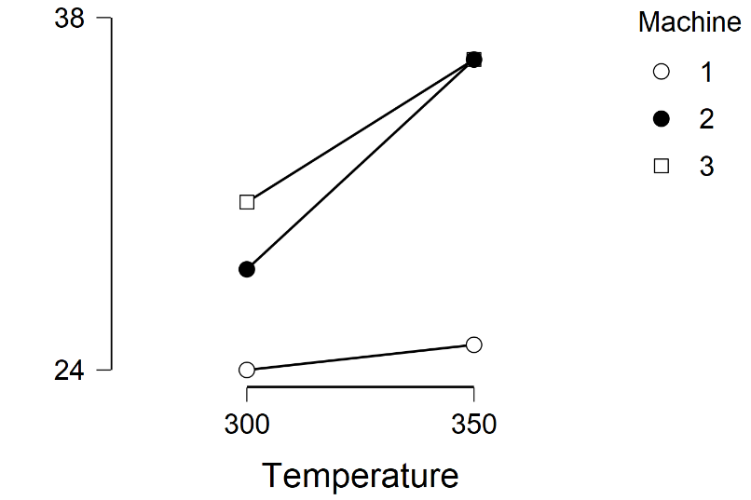

The within subject and between subject effects are both significant, as is their interaction. Moreover, they have large effect sizes (partial eta squared has been used). The post hoc tests indicate differences between machines 1 and 2, and between machines 1 and 3.
The plot for the estimated marginal means shows that for both temperatures, machine 1 produces the lowest average score. Machine 3 has a higher average score than machine 2 for the 300 degrees Celsius temperature but there was no clear difference between them at 350 degrees Celsius.

