Chapter 11
ANCOVA
The Therapies.csv file quantifies the success rates of clinical psychologists within a health authority. The therapy each psychologist uses has been categorized as cognitive-behavioral (CBT), humanistic or psychodynamic. The types of case examined in the study are eating disorders, depression, and personality disorders. Also measured is the average input time. (This study is a fictional one, as usual, based on the Iris data set.)
We are interested in whether or not the average time taken to treat the disorders is influenced by the different types of therapy (assuming, for example, that less time is typically required when CBT is used). Let us assume that researchers consider eating disorders in particular to be a cause of confusion, and would like to have the 'Eating' data taken into consideration as a potential cause of noise.

Check the assumptions before reporting the results but for simplicity, report the results 'as is' even though some assumptions may be violated. No data transformation will be conducted.
Set up ANCOVA as shown in the book, with InputTime as the dependent variable, Therapy as the factor and Eating as a covariate. The following options are suggested:
- Homogeneity tests
- Normality (Q-Q plot)
- Post hoc tests for Therapy (Tukey)
- Estimated marginal means section:
  - Therapy in 'Term 1'
  - Marginal Means plots
  - Equal cell weights
  - Error bars, confidence intervals option
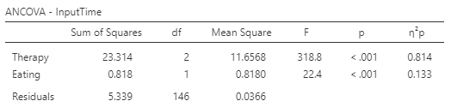
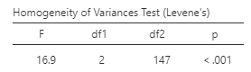

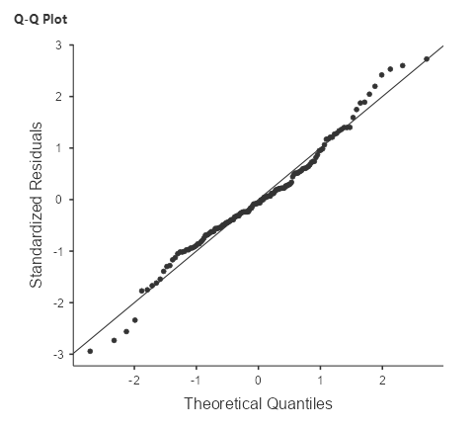

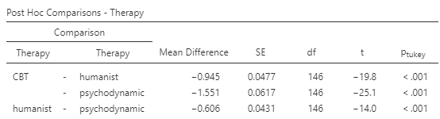

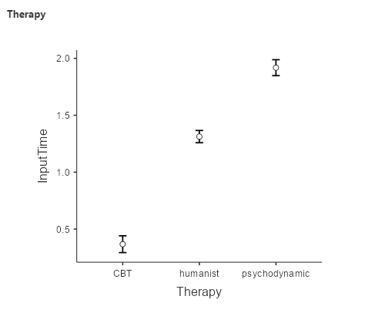

State the null and alternative hypotheses:
H0: The average time of treatment is the same for all therapies controlling for eating disorders
H1: The average time differs between at least two types of therapy controlling for eating disorders
What do the assumption results show?
The Levene’s Test statistic is significant (p <.05). Thus, the assumption of equality of variance was not met.
The normal Q-Q plot shows a satisfactory result. The standardized residuals plotted against their quantiles do not deviate from the normal line.
What do the ANCOVA results show?
The ANCOVA test shows a significant result both for the therapy and eating disorders.
What is the result of a post-hoc test to identify significant differences among therapies?
There are significant differences in treatment time between every type of therapy.

