Chapter 5 – Analysis of Differences

Exercise 1
- A medical intervention in a school classroom features an imaginary family, covering the existence of depression and ways of managing the condition. Students’ scores before and after the intervention – shown below – indicate their level of engagement with mental health issues. Explain what type of analysis is appropriate for this data set to determine whether or not there is a significant difference between the students’ scores before and after the intervention class.

- State the null and alternative hypotheses.

- Enter the data in Jamovi (Student Grades.csv file), editing the variable name, description, and data type properly.
Student | Before Intervention | After Intervention
1 | 18 | 22
2 | 21 | 25
3 | 16 | 17
4 | 22 | 24
5 | 19 | 16
6 | 24 | 29
7 | 17 | 20
8 | 21 | 23
9 | 23 | 19
10 | 18 | 20
11 | 14 | 15
12 | 16 | 15
13 | 16 | 18
14 | 19 | 26
15 | 18 | 18
16 | 20 | 24
17 | 12 | 18
18 | 22 | 25
19 | 15 | 19
20 | 17 | 16

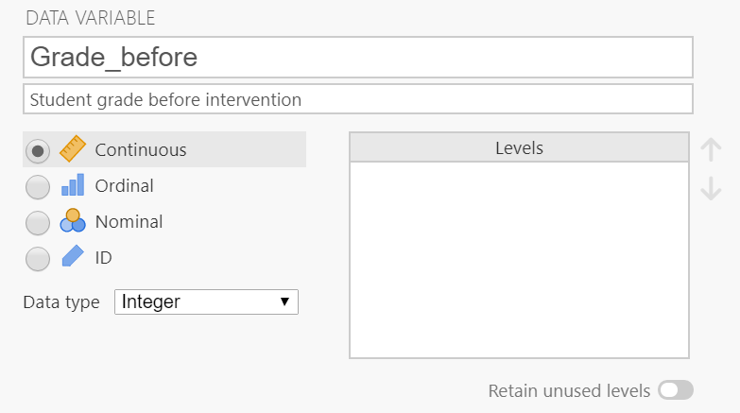

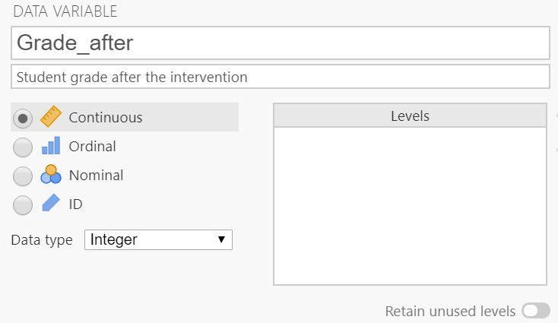
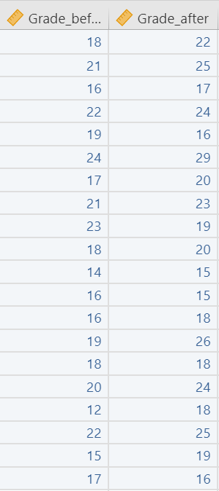
- Perform the appropriate analysis and interpret the results according to the formed hypothesis. Assume uncertainty about the direction of outcome (two-tailed test).

Exercise 2
A study assessed the effectiveness of a new drug designed to reduce repetitive behaviors in children affected with autism. A total of 8 children with autism enroll in the study and the amount of time that each child is engaged in repetitive behavior during three-hour observation periods are measured both before treatment and then again after taking the new medication for a period of 1 week. The data are shown below (you will also find this in the Drug Treatment.csv file).
Child | Before Technique | One Week of Technique
1 | 85 | 75
2 | 70 | 50
3 | 40 | 50
4 | 65 | 40
5 | 80 | 20
6 | 75 | 65
7 | 55 | 40
8 | 20 | 25

- Given this small dataset, explain what is the appropriate test to see if there is a significant difference between the median of two groups.

- State the null and alternative hypotheses.

- Enter the data in Jamovi. Make sure to edit the variable name, description, and data type.

- Perform the appropriate analysis and interpret the results according to the formed hypothesis.

Exercise 3
In an attempt to improve alertness scores for elderly people with dementia, two sets of exercise classes were performed. The scores were recorded as below.
Adult | Before Intervention | After First Exercise Class | After Second Exercise Class
1 | 18 | 22 | 20
2 | 21 | 25 | 22
3 | 16 | 17 | 20
4 | 22 | 24 | 26
5 | 19 | 16 | 15
6 | 24 | 29 | 30
7 | 17 | 20 | 25
8 | 21 | 23 | 26
9 | 23 | 19 | 25
10 | 18 | 20 | 23
11 | 14 | 15 | 20
12 | 16 | 15 | 14
13 | 16 | 18 | 22
14 | 19 | 26 | 24
15 | 18 | 18 | 19
16 | 20 | 24 | 23
17 | 12 | 18 | 25
18 | 22 | 25 | 27
19 | 15 | 19 | 22
20 | 17 | 16 | 20

- Explain why administering multiple t-tests would not be beneficial for this scenario. Which test is appropriate?

- State the null and alternative hypotheses.

- Load Adult Fitness.csv into JASP (unlike Jamovi, JASP has no data editing tool).

- Perform the appropriate analysis and interpret the results related to the hypothesis.

Exercise 4
Suppose that you want to compare the scores of participants from two different exercise classes for elderly adults, where the first class followed a traditional training method, whereas the second was an experimental class, applying a different teaching style. Do note that each separate group needs to be represented by a number (here, within the 'Class' variable); this would be the same with an ANOVA (independent samples / unrelated), only with more than 2 such numbers.

This data set is available in Teaching Methods.csv
Participant | Score | Class
1 | 18 | 1
2 | 21 | 1
3 | 16 | 1
4 | 22 | 1
5 | 19 | 1
6 | 24 | 1
7 | 17 | 1
8 | 21 | 1
9 | 23 | 1
10 | 18 | 1
11 | 14 | 1
12 | 16 | 1
13 | 16 | 1
14 | 19 | 1
15 | 18 | 1
16 | 20 | 1
17 | 12 | 1
18 | 22 | 1
19 | 15 | 1
20 | 17 | 1
21 | 22 | 2
22 | 25 | 2
23 | 17 | 2
24 | 24 | 2
25 | 16 | 2
26 | 29 | 2
27 | 20 | 2
28 | 23 | 2
29 | 19 | 2
30 | 20 | 2
31 | 15 | 2
32 | 15 | 2
33 | 18 | 2
34 | 26 | 2
35 | 18 | 2
36 | 24 | 2
37 | 18 | 2
38 | 25 | 2
39 | 19 | 2
40 | 16 | 2

- State the null and alternative hypotheses.

- Which test is appropriate here?

- Input the data in Jamovi. Make sure to edit the variables data type accordingly to be able to perform the test.

- Perform the analysis and interpret the results.

