Chapter 12
MANOVA
Using the Injuries.csv dataset, instead of treating limb injuries ('ArmLeg') as a covariant (as in the ANCOVA exercise), analyze it as a separate dependent variable. Thus, use MANOVA to evaluate if limb injuries and Time differ significantly per injury source.
Check the assumptions before reporting the results but for simplicity, report the results 'as is' even though some assumptions may be violated. No data transformation will be conducted.
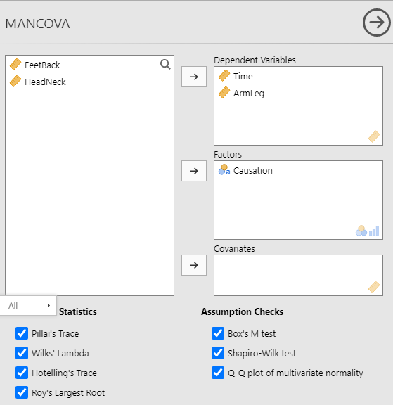

Box's Homogeneity of Covariance Matrices Test
χ² |  | df |  | p
58.9 |  | 6 |  | < .001

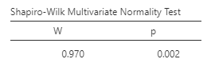

Q-Q Plot Assessing Multivariate Normality
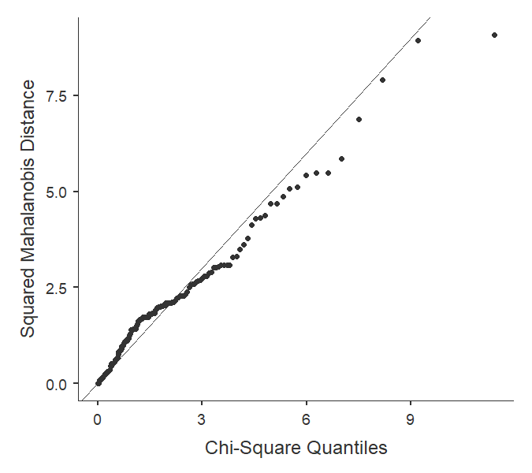
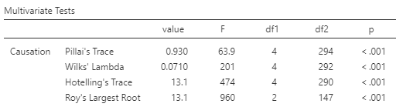
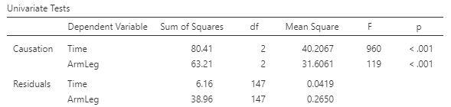
What do the assumption tests show?
Both sphericity and normality assumptions were not met.

What does the MANOVA show?
The multivariate analysis is significant (p <.001) showing that at least one of the two variables differs between the injury sources. Looking at the univariate results, both treatment time and limb injuries have significantly different mean values among the injury sources.

