Chapter 11
ANCOVA
The Injuries.csv file quantifies injuries sustained by young adults in different hospitals. The injuries have been categorized according to the source of the injury: occupational, traffic and street violence. Measures include the injury type – arm/leg, feet/back, head/neck – and the amount of training provided. (This study is a fictional one, based on the Iris data set.)
We are interested in whether or not the average time taken to treat the injuries is influenced by the different sources of injuries (assuming, for example, that less time is required to treat occupational injuries). Let us assume that researchers consider limb injuries in particular to be a cause of confusion, and would like to have the 'ArmLeg' data taken into consideration as a potential cause of noise.

Check the assumptions before reporting the results but for simplicity, report the results 'as is' even though some assumptions may be violated. No data transformation will be conducted.
Set up ANCOVA as shown in the book, with Time as the dependent variable, Causation as the factor and ArmLeg as a covariate. The following options are suggested:
- Homogeneity tests
- Normality (Q-Q plot)
- Post hoc tests for Causation (Tukey)
- Estimated marginal means section:
  - Causation in 'Term 1'
  - Marginal Means plots
  - Equal cell weights
  - Error bars, confidence intervals option
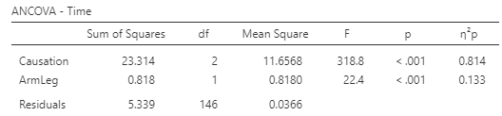
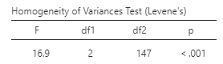

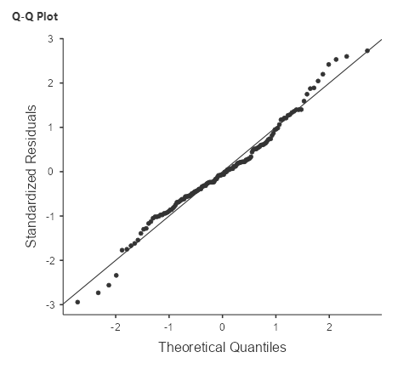

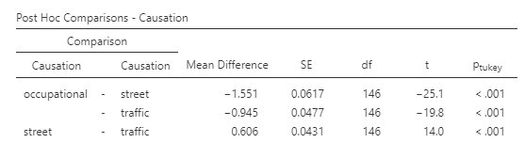

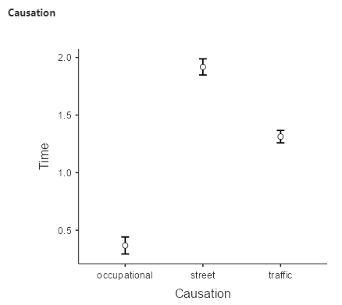

State the null and alternative hypotheses:
H0: The average time of treatment is the same for all injury sources controlling for the number of limb injuries
H1: The average time differs between at least two types of injury source controlling for injuries to limbs.
What do the assumption results show?
The Levene’s Test statistic is significant (p <.05). Thus, the assumption of equality of variance was not met.
The normal Q-Q plot shows a satisfactory result. The standardized residuals plotted against their quantiles do not deviate from the normal line.
What do the ANCOVA results show?
The ANCOVA test shows a significant result both for the injury source and limb injuries.
What is the result of a post-hoc test to identify significant differences among injury sources?
There are significant differences in treatment time between every type of injury source.

