Chapter 11
ANCOVA
The High Jump.csv file quantifies injuries sustained by schoolchildren in different regions practising the high jump. The injuries have been categorized according to the technique used at the time of injury: Scissors jump, Western roll and Fosbury flop. Measures include the injury type – arm/leg, feet/back, head/neck – and the amount of training provided. (This study is a fictional one, based on the Iris data set.)
We are interested in whether or not the duration of training provision has been allocated differentially for the different types of high jump (assuming, for example, that beginners are more likely to start with the scissors method). Let us assume that trainers consider limb injuries in particular to be a cause of confusion, and would like to have the 'ArmLeg' data taken into consideration as potential cause of noise.

Check the assumptions before reporting the results but for simplicity, report the results 'as is' even though some assumptions may be violated. No data transformation will be conducted.
Set up ANCOVA as shown in the book, with Training as the dependent variable, Jump as the factor and ArmLeg as a covariate. The following options are suggested:
- Homogeneity tests
- Normality (Q-Q plot)
- Post hoc tests for Jump (Tukey)
- Estimated marginal means section:
  - Jump in 'Term 1'
  - Marginal Means plots
  - Equal cell weights
  - Error bars, confidence intervals option
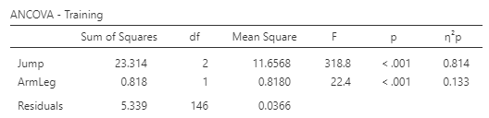

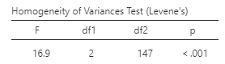

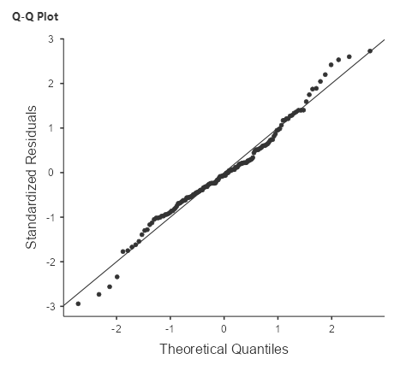

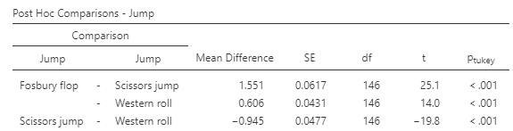

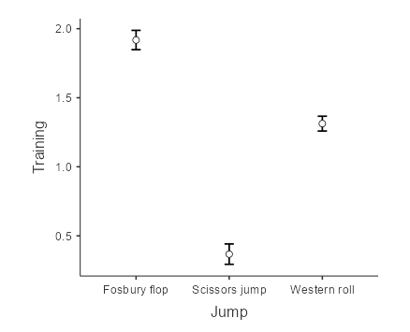

State the null and alternative hypotheses:
H0: The average time of training provision is the same for all jump techniques controlling for the number of limb injuries
H1: The average training period differs between at least two types of jump technique controlling for injuries to limbs.
What do the assumption results show?
The Levene’s Test statistic is significant (p <.05). Thus, the assumption of equality of variance was not met.
The normal Q-Q plot shows a satisfactory result. The standardized residuals plotted against their quantiles do not deviate from the normal line.
What do the ANCOVA results show?
The ANCOVA test shows a significant result both for the jump method and limb injuries.
What is the result of a post-hoc test to identify significant differences among jump techniques?
There are significant differences in training provision between every type of jump technique.

