Chapter 18: The Kaplan Meier Survival Function
20 senior police officers in a region are monitored for 24 years. During that time, some leave policing. Censoring occurs either when the study ends or they are lost to follow-up.
Load the data (Police Leaving.csv) in Jamovi and analyze the Kaplan-Meier curve. If this is the first time you have used this application, load the 'Death Watch' module into Jamovi.
Year | Departure
1 | Left
2 | Censored
3 | Left
5 | Left
6 | Censored
8 | Left
9 | Censored
10 | Censored
12 | Censored
13 | Censored
14 | Left
16 | Left
17 | Left
18 | Censored
19 | Censored
20 | Left
21 | Censored
22 | Left
23 | Left
24 | Censored

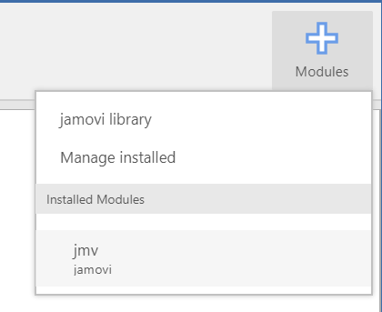
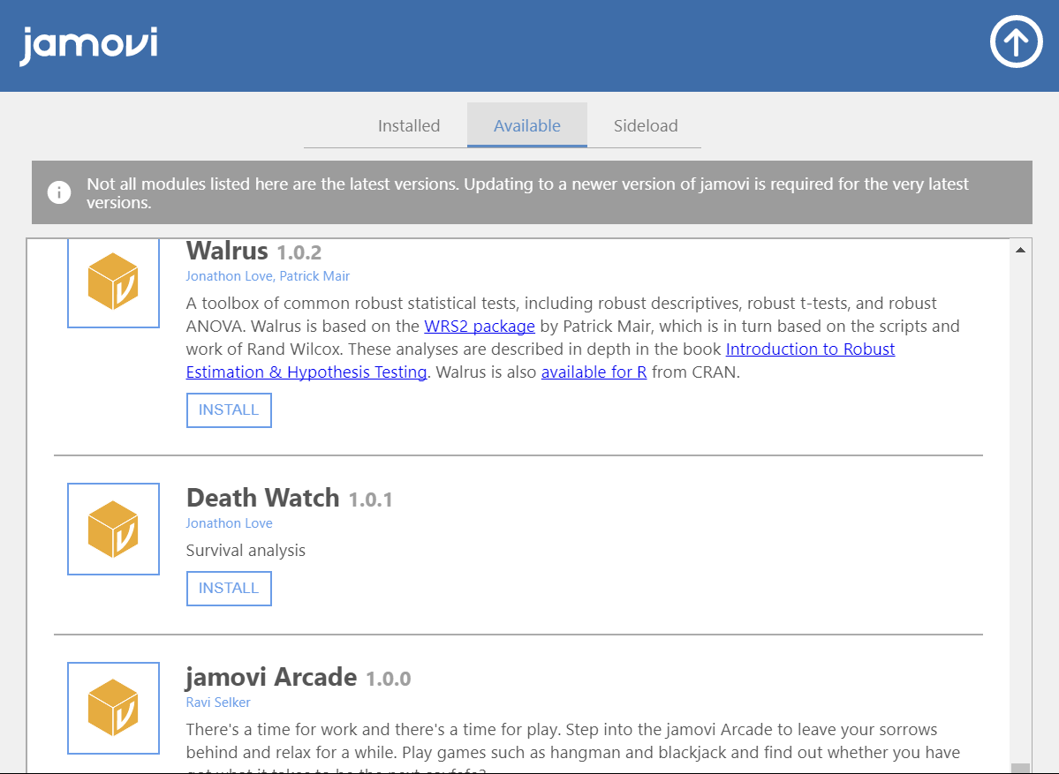

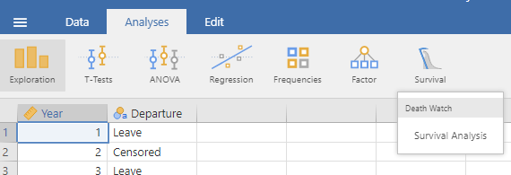

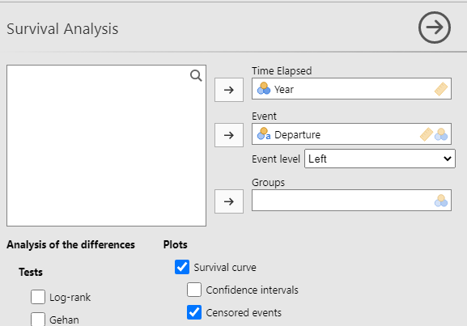

Survival Analysis
