Chapter 12
MANOVA
Using the Sentence.csv dataset, instead of treating 'Religiosity' as a covariant (as in the ANCOVA exercise), analyze it as a separate dependent variable. Thus, use MANOVA to evaluate if religiosity and duration of sentence differ significantly per conviction category.
Check the assumptions before reporting the results but for simplicity, report the results 'as is' even though some assumptions may be violated. No data transformation will be conducted.
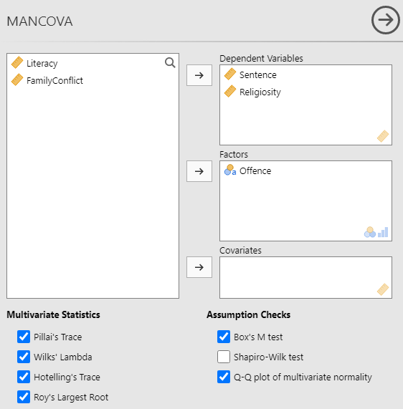

Box's Homogeneity of Covariance Matrices Test
χ² |  | df |  | p
58.9 |  | 6 |  | < .001

Q-Q Plot Assessing Multivariate Normality
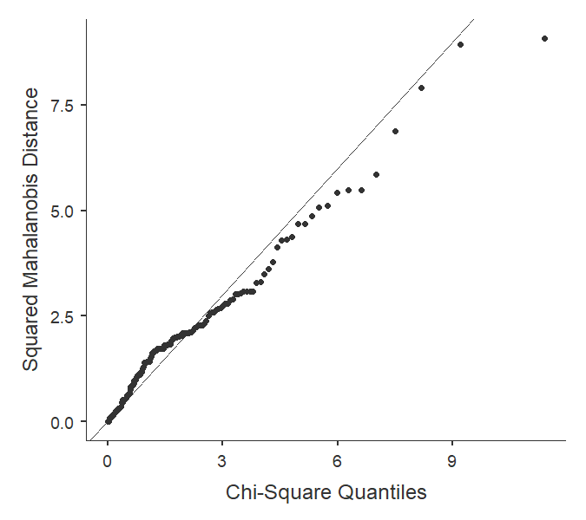

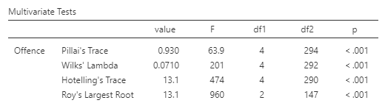
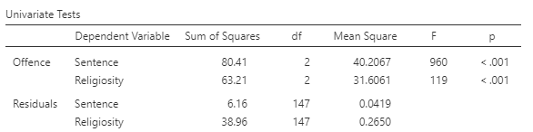
What do the assumption tests show?
Both sphericity and normality assumptions were not met.

What does the MANOVA show?
The multivariate analysis is significant (p <.001) showing that at least one of the two variables differs between conviction categories. Looking at the univariate results, both sentence duration and religiosity have significantly different mean values across the conviction categories.

