Chapter 14 - MANOVA
The Iris dataset quantifies the morphological variation of Iris flowers of three related species. It consists of 50 samples from each of three species of Iris—Iris setosa, Iris virginica, and Iris versicolor. The length and the width of the sepals and petals in centimeters were measured for each sample to compare the features per species.

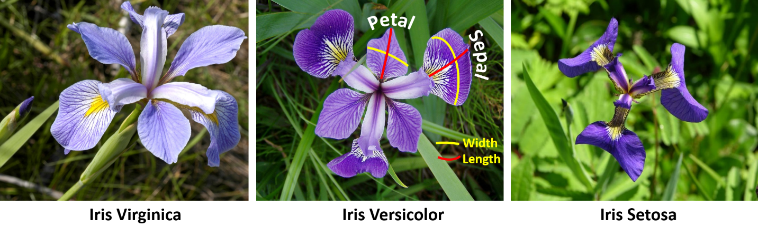
The data set Iris_data.csv contains this information. Use MANOVA to find out if petal width and sepal length differ significantly between species.
Which variables are dependent and independent variables?

For speed, ignore the usual assumption checks for parametric tests. Check the assumptions specific to MANOVA before reporting the MANOVA results but for simplicity, report the results 'as is' even though some assumptions may be violated. No data transformation will be conducted. For the MANOVA, just perform the basic version as shown first in the book, followed by the univariate test procedure based on the initial model.

What do the assumption tests show?

What does the MANOVA show?

